Describe the problem that your idea will address. (450 characters)

**Pitch:**

$[X], [Y] man hours and [3] months every time Australia’s biggest employers run graduate

recruitment. Hundreds of companies, dozens of applications and a world of pressure every time Australia’s brightest students look to their future. What if there was a better way? The team is revolutionising the graduate recruitment process, with a centralised listing platform that provides real time tracking and one-click applications for students while funneling the best candidates to companies. Why Jeebs? Because we ceebs jobs.

**Problem-specific:**

Close to half of students don't use anything to keep track of their applications for intern and graduate roles. It's no wonder that over 75% forget to apply or progress their applications during the process. It's just as bad for the other side: [$5,000] & [3 man hours] for every new graduate and [3] months every time Australia’s biggest employers run graduate recruitment. What if there was another way? Jeebs is a centralised listing platform that provides real time tracking and one-click applications for students while funneling the best candidates to companies.

**Final version:**

77% of students forget to apply to graduate roles, driven meaningfully by the 45% who don’t use any tracking tools to help them, and over 90% don’t enjoy the process. From a commercial perspective, some estimates put the cost of a single graduate recruit at $5,000, not withstanding the tens of hours of resume screening and interviewing. Graduate recruitment also has some of the highest turnover in the HR industry. For such a momentous point for both students and companies, the Jeebs team is sure there is another way.

Describe the ‘problem’ (need, issue, opportunity) that your idea will address.

77% of students forget to apply to graduate roles, partially driven by the 45% who don’t utilise tracking tools, with 90% not enjoying the process. Commercially, estimates put the cost of a single graduate recruit at $5,000, notwithstanding hours of CV screening and interviewing. Graduate recruiters have some of the highest turnover in the HR industry. For such a momentous point for both students and companies, Jeebs is sure there is another way.

How big and widespread is the problem (please estimate the size and extent of the problem and who experiences it. e.g. all UNSW first year engineering students).

The problem is faced by the proportion of penultimate and final year university students searching for internships and graduate roles in highly corporatised industries, including Business, Law, Engineering and Software Development. Higher Education figures suggest this sits around 105,000 domestic students every year who face a recruitment process that is convoluted and tiresome while also draining company resources of up to $525m annually.

What’s your startup idea?

Our platform centralises all grad/intern listings onto one platform with the ability to track applications throughout the candidate journey. A forum exists where students can discuss the process with each other and employers. Finally, a machine learning algorithm generates a success rate prediction, giving an indication of how likely a student would succeed in and enjoy a specific role given factors such as previous experiences and interests.

What is novel (new/different/unique) to what currently exists about your idea?

At the moment, no platforms exist that centralise all job listings from multiple sources online and allow students to easily search for relevant opportunities. Furthermore, our proprietary machine learning algorithm provides a success rate prediction viewable to both students and employers, guiding students to apply for jobs they’re well-fitted to and giving employers an automated method for filtering candidates.

Is your idea legal?

Yes lol HAHAHAHA

What capabilities does your team need to develop and advance your idea?

* Persuasion, pitching and public speaking
* Creativity
* Collaboration
* Understanding and defining the problem
* **Mapping and understanding the market and competitive landscape**
* Identifying and understanding customer/users
* **Exploring and validation solutions including value proposition and comp advantage**
* **Business models and business model design**

Select all the themes relevant to your business:

* Data & Analytics
* EduTech

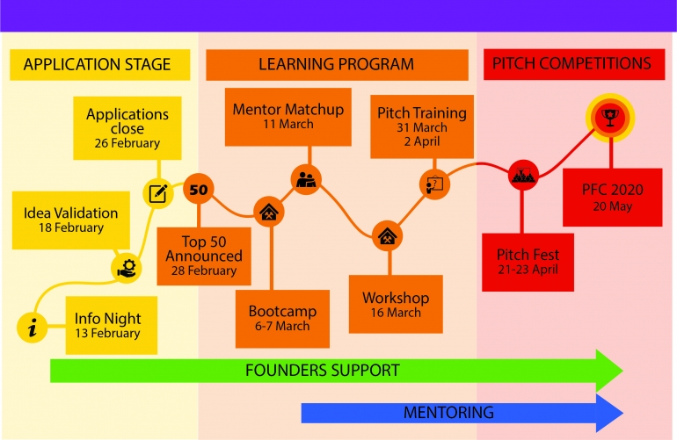

* 21-23 April Pitching -

**General thoughts;**

* Would be useful to get feedback on MVP prior to PFC program
  + Congested market with high barriers to entry for final product - will be useful for them to understand there’s demand for the product
* Momentum depends on quality of feedback/level of features we want to implement prior to formal launch

**MVP Release Plan:**

* Distribution channels:
  + UNSW Discussion Group
  + UNSW CSESoc
  + (Contingent on how well it works) - UCC/B1/BSoc/FMAA/UNIT
  + USyd/UTS/Macquarie - wherever else we launched surveys
  + Emails
  + Flyers lay around uni
* Messaging:
  + General: “Use this to make sure you haven’t missed any upcoming apps/dates”
  + Career minded teens: “Track it and see everything on a single page”
  + Techies: “Working o bden recruitment platform - would be keen for feedback”
* Purpose:
  + Feedback should be #1 priority - too early stage to start focusing on developing consistent users/brand - don’t want to build a reliance if we’re planning to make substantial changes/downtime in the middle of application period
  + Run process for agreed upon testing - potentially from day 0 until close of mainstream application period (end March?)
    - Use wrap up of recruitment period to begin building brand awareness
      * Congratulation emails to users for passing apps etc.